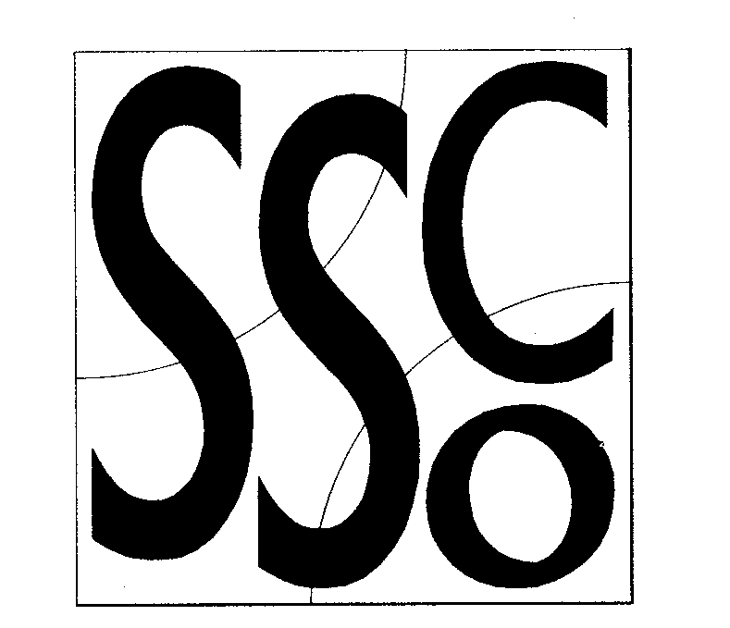

Teaching points.
Try to vary the size and shape of the ball being used.
Communication is vital to being successful in this drill.
Pupils tend to let their throwing technique deteriorate due to the need for concentration, you must emphasise the need for pupils to create targets with the hands when catching.

Throwing Cross
MULTI SKILL CARDS



Classification;
Body awareness
Equipment:
Cones in 2 colours
Coloured bands
Different sized and shaped balls
chalk
Differentiation
Progressions. To make the activity harder you may
- include smaller objects into the drill which are harder to catch
- see if pupils can complete the drill whilst not communicating
- increase the size of the grid so pupils have to throw the ball further.

To simplify:
- Decrease distance between cones.
- Increase the size of the balls which are easier to catch
- Assist pupils with communication and timing.
Activity key points

- The following exercise requires a great deal of concentration which therefore challenges pupils throwing skills.
- To begin you place 4 markers as shown and in
the centre of the grid draw a large letter R
in chalk
- Split group into 4 equal teams (max 5 per marker) with those on a red cone wearing a red bib and those on a green cone wearing a green bib.
- Starting with a ball which is easy to catch, one pupil walks into the centre of the grid, stands on the R and passes the ball to their right. They then continue to walk forward and join the queue opposite. The person with the ball then does the same on the ball is continually passed around the grid, gradually increasing the speed as pupils become accustomed to the drill. Pupils should count how many consecutive throws are completed without dropping the ball.
- The next step is to introduce another ball. Remember to always start with the balls at opposite sides of the grid (i.e. the first pupils in the two red queues)
- Using the words Go and Throw as cues pupils walk towards each other and both throw to their right at the same time.
- You can add balls until you have 4 balls being thrown in the grid.
- The aim is to complete as many consecutive passes as possible without dropping the ball.

4m

